EXPERIMENT-5

Question 1: Queries with Subquery and Correlated Query
Scenario: A college maintains two tables, Student and Department, to store student details and department information. The college administrator wants to identify students who belong to departments with a higher-than-average student age and retrieve students whose age is greater than the average age of their respective departments.
Question: Write SQL queries to perform the following operations:Display the details of students whose age is greater than the average age of all students using a subquery.Display the names of students who belong to the CSE department using a subquery.Display the details of students whose age is greater than the average age of students in their respective departments using a correlated subquery.Display the names of students who belong to departments having more than five students using a subquery.

Queries with Subquery and Correlated Query
Aim:
To write SQL queries using subqueries and correlated subqueries to retrieve student details based on age and department.
Step 1: Create the tables
CREATE TABLE Department (
Dept_ID INT PRIMARY KEY,
Dept_Name VARCHAR(50) NOT NULL
);

CREATE TABLE Student (
Student_ID INT PRIMARY KEY,
Student_Name VARCHAR(50) NOT NULL,
Age INT,
Dept_ID INT,
FOREIGN KEY (Dept_ID) REFERENCES Department(Dept_ID)
);
Step 2: Insert the data
INSERT INTO Department VALUES
(1, 'CSE'),
(2, 'ECE'),
(3, 'IT');

INSERT INTO Student VALUES
(101, 'Arun', 20, 1),
(102, 'Priya', 19, 2),
(103, 'Kumar', 22, 1),
(104, 'Ravi', 21, 2),
(105, 'Meena', 23, 1),
(106, 'Divya', 18, 3),
(107, 'Rahul', 24, 1),
(108, 'Sneha', 20, 2),
(109, 'Ajay', 25, 1),
(110, 'Nisha', 19, 3),
(111, 'Karthik', 22, 1),
(112, 'Anu', 21, 1);
Step 3: Display students older than the average age of all students
SQL Query:
SELECT *
FROM Student
WHERE Age > (SELECT AVG(Age) FROM Student);
Explanation:
- The subquery calculates the average age of all students.
- The outer query displays students whose age is greater than that average.
Output:
Average age = \(254 \div 12 = 21.17\)
Student_ID | Student_Name | Age | Dept_ID
103 | Kumar | 22 | 1
105 | Meena | 23 | 1
107 | Rahul | 24 | 1
109 | Ajay | 25 | 1
111 | Karthik | 22 | 1

Step 4: Display the names of students belonging to the CSE department
SQL Query:
SELECT Student_Name
FROM Student
WHERE Dept_ID = (
SELECT Dept_ID
FROM Department
WHERE Dept_Name = 'CSE'
);
Explanation:
- The subquery retrieves the department ID of CSE.
- The outer query displays students who belong to that department.

Output:
Student_Name
Arun
Kumar
Meena
Rahul
Ajay
Karthik
Anu

Step 5: Display students older than the average age of their respective departments
SQL Query (Correlated Subquery):
SELECT *
FROM Student S
WHERE S.Age > (
SELECT AVG(S2.Age)
FROM Student S2
WHERE S2.Dept_ID = S.Dept_ID
);
Explanation:
- The inner query calculates the average age for the department of each student.
- The outer query compares each student's age with their own department's average.
- Students older than their department average are displayed.

Output:
Student_ID | Student_Name | Age | Dept_ID
104 | Ravi | 21 | 2
105 | Meena | 23 | 1
107 | Rahul | 24 | 1
109 | Ajay | 25 | 1
110 | Nisha | 19 | 3

Step 6: Display names of students belonging to departments with more than five students
SQL Query:
SELECT Student_Name
FROM Student
WHERE Dept_ID IN (
SELECT Dept_ID
FROM Student
GROUP BY Dept_ID
HAVING COUNT(*) > 5
);
Explanation:
- GROUP BY groups students according to their department.
- HAVING COUNT(*) > 5 selects departments containing more than five students.
- The outer query displays the names of students in those departments.

Output:
Student_Name
Arun
Kumar
Meena
Rahul
Ajay
Karthik
Anu

Result:
Thus, SQL subqueries and a correlated subquery were used to retrieve students based on the overall average age, CSE department membership, department-wise average age, and departments with more than five students.
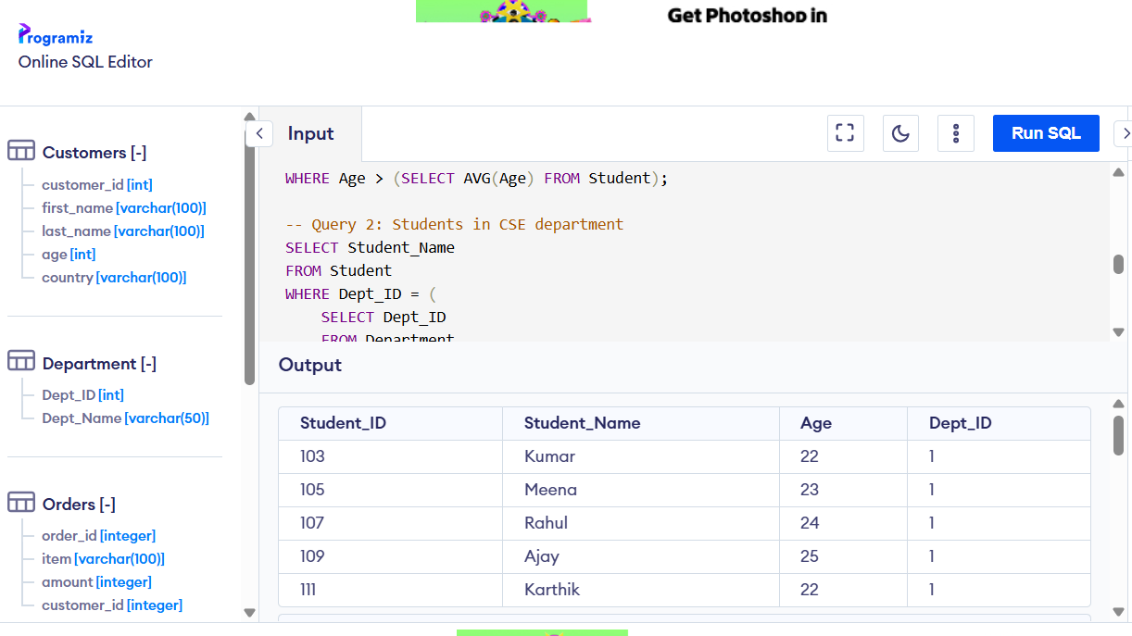
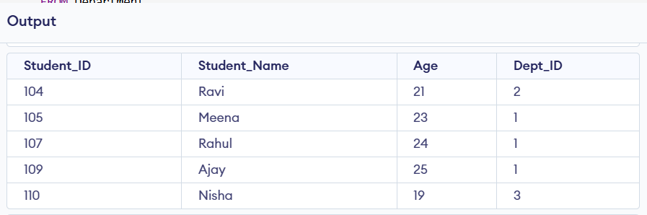
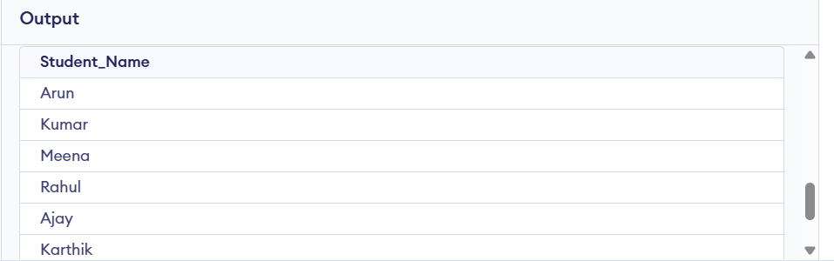

EXPERIMENT-6

Question 2: Queries with Joins – EquiJoin, Inner Join, and Outer Join
Scenario: A college maintains two tables, Student and Department. The Student table stores student ID, student name, and department ID, while the Department table stores department ID and department name. The administrator wants to retrieve student details along with their corresponding department information.
Question: Write SQL queries to perform the following operations:Display student names and department names using an EquiJoin.Retrieve student details along with department names using an Inner Join.Display all students, including those who are not assigned to any department, using a Left Outer Join.Display all departments, including those that do not have any students, using a Right Outer Join.Display all students and all departments, including unmatched records, using a Full Outer Join.

Queries with Joins – EquiJoin, Inner Join, and Outer Join
Aim:
To perform EquiJoin, Inner Join, Left Outer Join, Right Outer Join, and Full Outer Join on Student and Department tables.
Step 1: Create the tables
CREATE TABLE Department (
Dept_ID INT PRIMARY KEY,
Dept_Name VARCHAR(50) NOT NULL
);

CREATE TABLE Student (
Student_ID INT PRIMARY KEY,
Student_Name VARCHAR(50) NOT NULL,
Dept_ID INT
);

Step 2: Insert sample data
INSERT INTO Department VALUES
(1, 'CSE'),
(2, 'ECE'),
(3, 'IT'),
(4, 'MECH');

INSERT INTO Student VALUES
(101, 'Arun', 1),
(102, 'Priya', 2),
(103, 'Kumar', 1),
(104, 'Divya', NULL),
(105, 'Ravi', 5);
Step 3: EquiJoin
Query: Display student names and department names using an EquiJoin.
SELECT S.Student_Name, D.Dept_Name
FROM Student S, Department D
WHERE S.Dept_ID = D.Dept_ID;
Explanation: The WHERE condition matches rows where the department IDs are equal.
Output:
Student_Name | Dept_Name
Arun | CSE
Priya | ECE
Kumar | CSE

Step 4: Inner Join
Query: Retrieve student details along with department names.
SELECT S.Student_ID, S.Student_Name, S.Dept_ID, D.Dept_Name
FROM Student S
INNER JOIN Department D
ON S.Dept_ID = D.Dept_ID;
Explanation: Displays only students with a matching department.
Output:
Student_ID | Student_Name | Dept_ID | Dept_Name
101 | Arun | 1 | CSE
102 | Priya | 2 | ECE
103 | Kumar | 1 | CSE

Step 5: Left Outer Join
Query: Display all students, including those not assigned to a matching department.
SELECT S.Student_ID, S.Student_Name, S.Dept_ID, D.Dept_Name
FROM Student S
LEFT OUTER JOIN Department D
ON S.Dept_ID = D.Dept_ID;
Explanation: Displays every student. If no department matches, the department name is NULL.

Output:
Student_ID | Student_Name | Dept_ID | Dept_Name
101 | Arun | 1 | CSE
102 | Priya | 2 | ECE
103 | Kumar | 1 | CSE
104 | Divya | NULL | NULL
105 | Ravi | 5 | NULL

Step 6: Right Outer Join
Query: Display all departments, including departments without students.
SELECT S.Student_ID, S.Student_Name, D.Dept_ID, D.Dept_Name
FROM Student S
RIGHT OUTER JOIN Department D
ON S.Dept_ID = D.Dept_ID;
Explanation: Displays every department. If no student belongs to a department, the student details are NULL.
Output:
Student_ID | Student_Name | Dept_ID | Dept_Name
101 | Arun | 1 | CSE
103 | Kumar | 1 | CSE
102 | Priya | 2 | ECE
NULL | NULL | 3 | IT
NULL | NULL | 4 | MECH
Step 7: Full Outer Join
Query: Display all students and departments, including unmatched records.
SELECT S.Student_ID, S.Student_Name, D.Dept_ID, D.Dept_Name
FROM Student S
FULL OUTER JOIN Department D
ON S.Dept_ID = D.Dept_ID;
Explanation: Displays matching records and all unmatched student and department records. Missing values appear as NULL.
Output:
Student_ID | Student_Name | Dept_ID | Dept_Name
101 | Arun | 1 | CSE
102 | Priya | 2 | ECE
103 | Kumar | 1 | CSE
104 | Divya | NULL | NULL
105 | Ravi | NULL | NULL
NULL | NULL | 3 | IT
NULL | NULL | 4 | MECH

Note: In the Full Outer Join output, Ravi's Dept_ID = 5 has no matching department, so the department columns are NULL. Divya has no assigned department, so the student columns are retained with NULL department details.
If your SQL compiler does not support RIGHT OUTER JOIN or FULL OUTER JOIN (for example, some MySQL setups), these queries need an alternative using LEFT JOIN and UNION.
Result
Thus, EquiJoin, Inner Join, Left Outer Join, Right Outer Join, and Full Outer Join were used to retrieve matching and unmatched records from the Student and Department tables.

